AI ASSITANT CODING
ASSIGNMENT-20
M.SHIVAMANI
2303A52344
BATCH-38

Task 1 – Password Security Enhancement Task:
Analyze an AI-generated Python program that stores passwords in plain text and improve its security.

Prompts Used:
Prompt1:
Generate a simple Python program for user registration and login that stores usernames and passwords. Keep it basic without using any encryption or hashing.
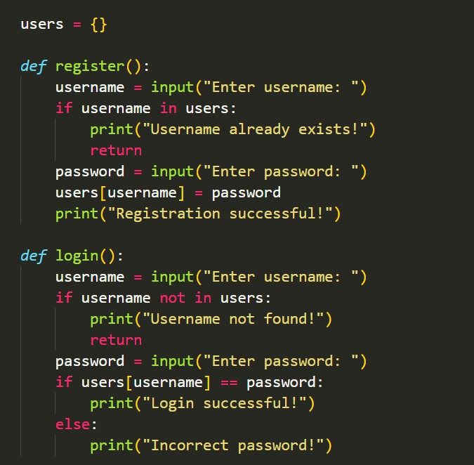

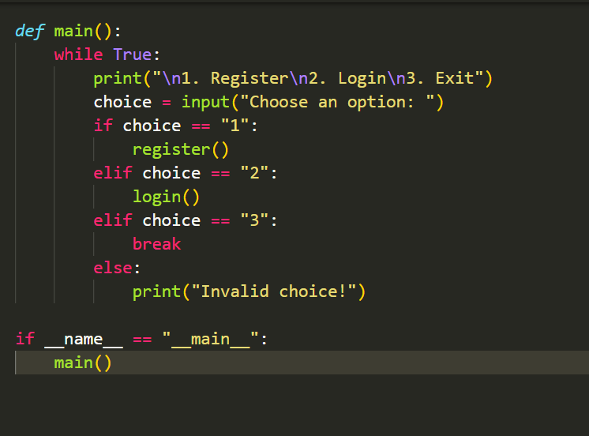
Prompt 2:
Analyze the following Python code and identify security issues related to password storage. Explain the risks of storing passwords in plain text.
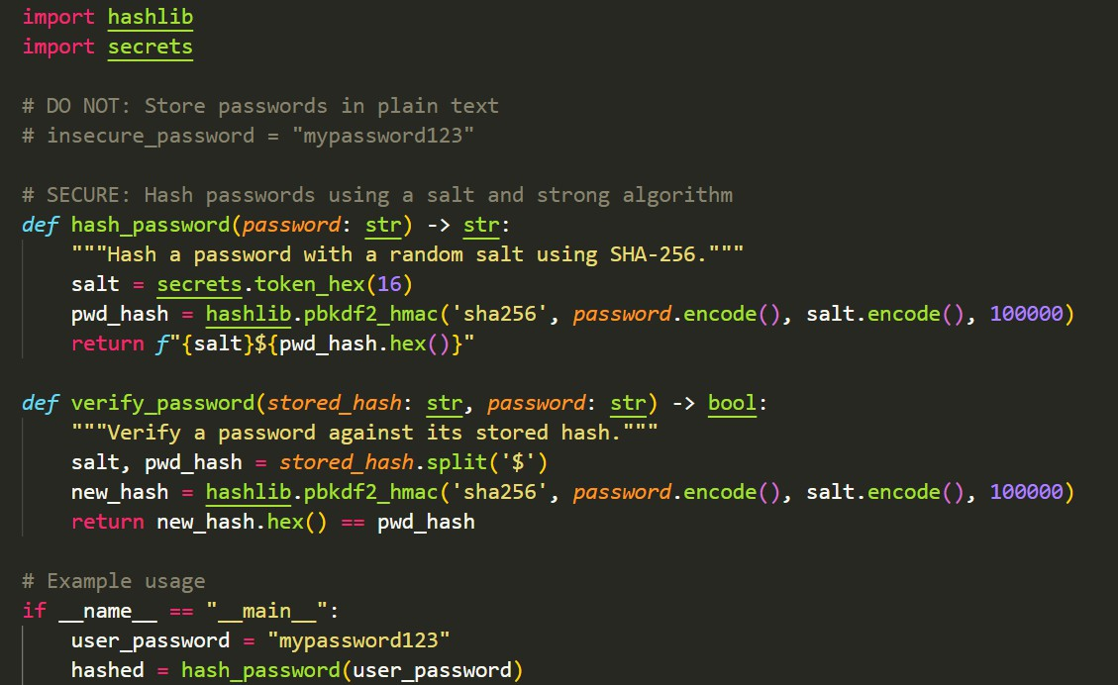

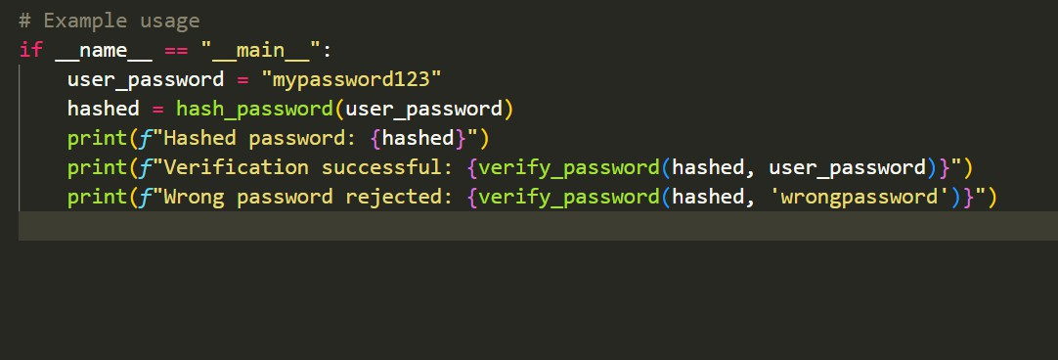
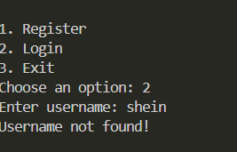
Prompt 3:
Refactor the given Python code to store passwords securely using hashing (bcrypt or hashlib). Ensure proper user authentication is implemented.

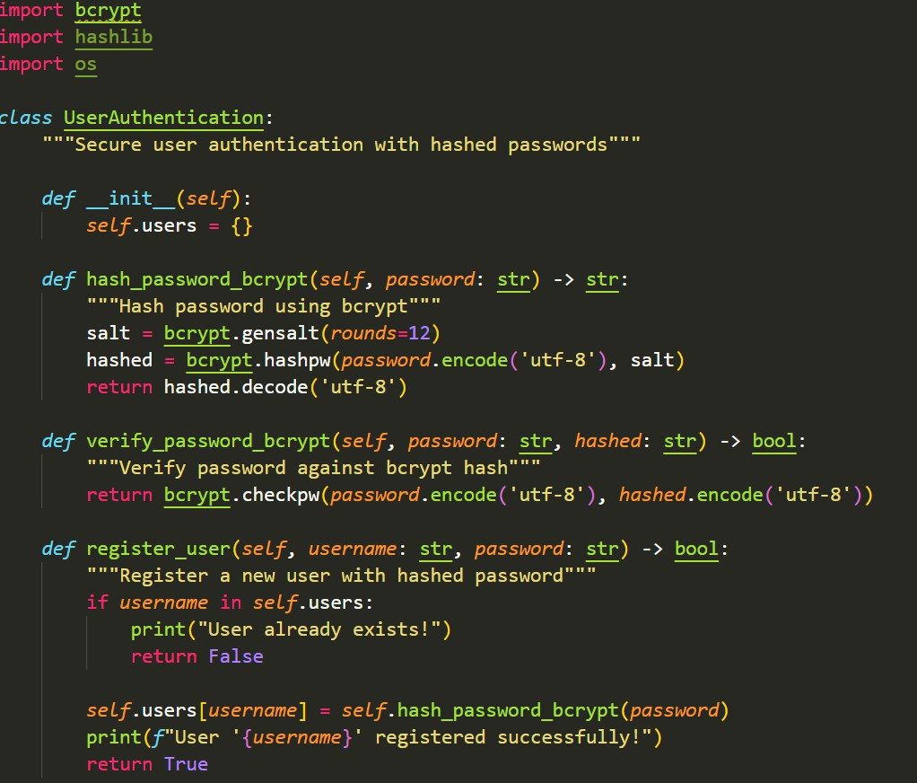

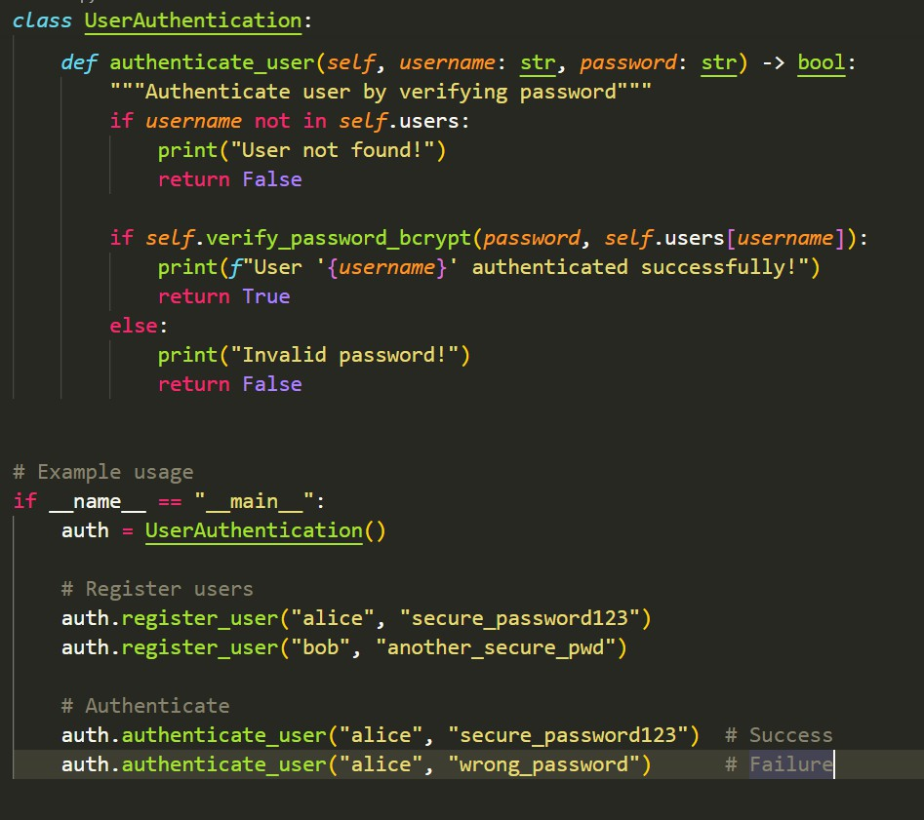
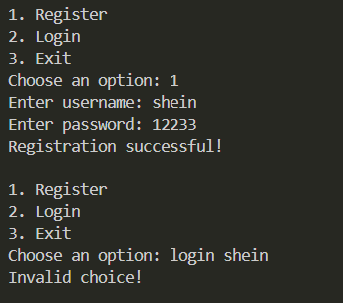

Explanation-

The AI-generated program initially stored passwords in plain text, which is a major security vulnerability. If the database is compromised, attackers can directly access user credentials. To improve security, password hashing techniques such as bcrypt or hashlib are used.
Hashing converts passwords into irreversible encrypted forms, ensuring that even if data is leaked, the original passwords cannot be retrieved. This enhances authentication security and protects user data.

Task 2 – Secure API Key Management Task:
Evaluate an AI-generated script that uses hardcoded API keys and

Prompt 1 (Generate Insecure Code)
Generate a Python script that connects to an external API using a hardcoded API key.

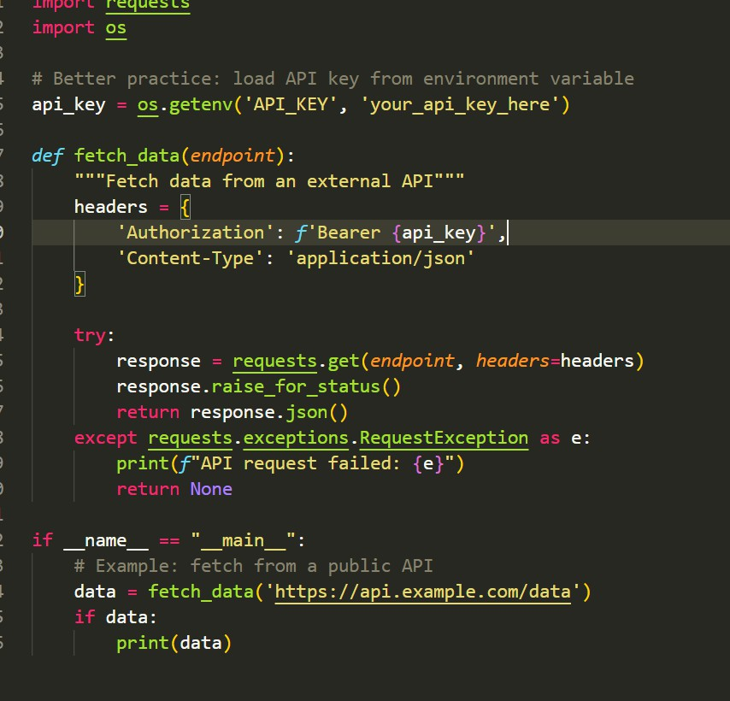
Prompt 2 (Security Analysis)
Identify the security risks of using hardcoded API keys in a Python program. Explain why this approach is unsafe.

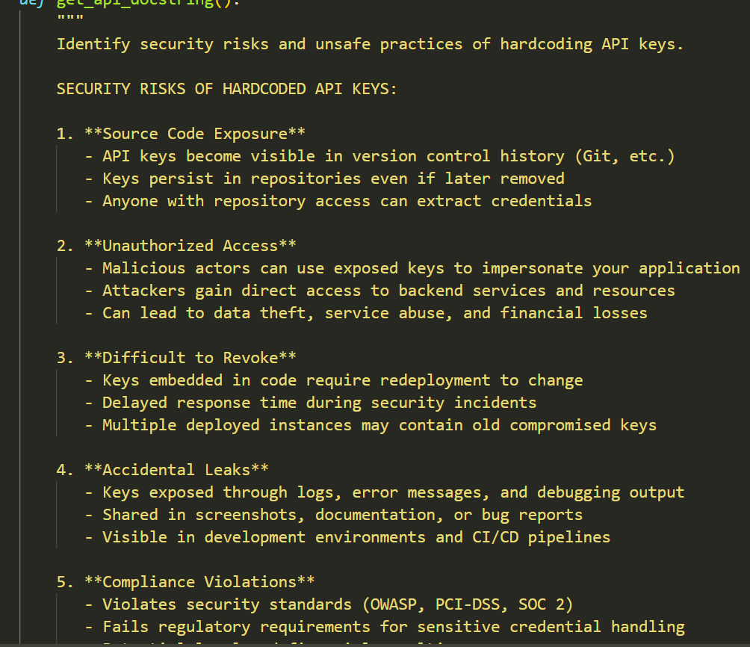

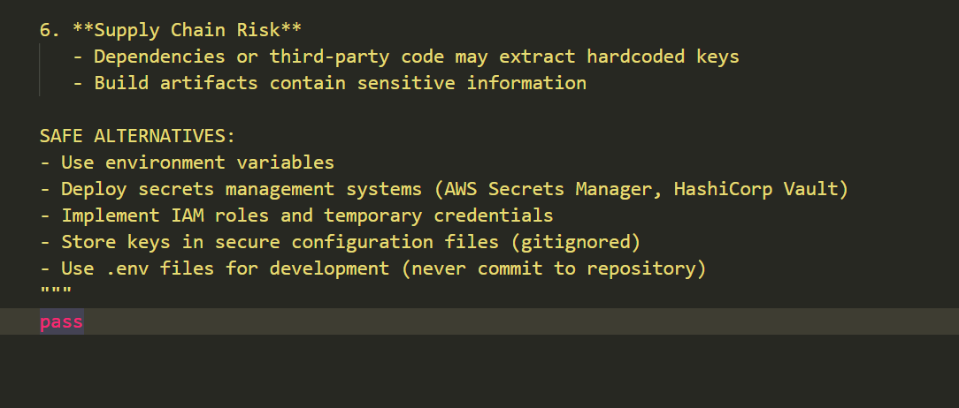
Prompt 3 (Secure Refactoring)
Modify the Python script to securely access the API key using environment variables instead

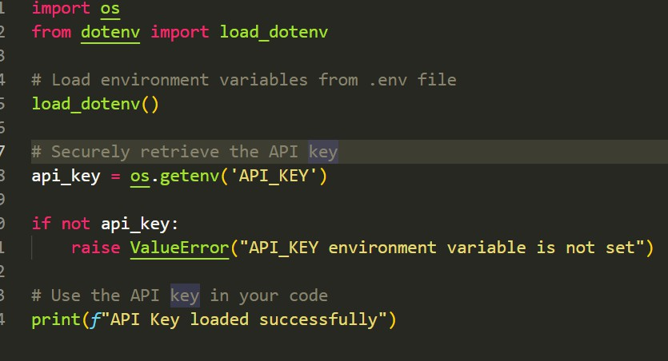
Explanation-
The original script used hardcoded API keys, which is insecure because sensitive credentials can be exposed through source code sharing or version control systems. This can lead to unauthorized API usage and data breaches. The improved approach uses environment variables to store API keys securely. This ensures that sensitive information is not directly embedded in the code, improving confidentiality and making the application more secure and scalable.

Task 3 – Weak Encryption Detection Task:
Examine an AI-generated program that uses weak encryption techniques and strengthen it.
Prompt
Generate a simple Python program that performs encryption and decryption using a basic method like Base64 encoding.

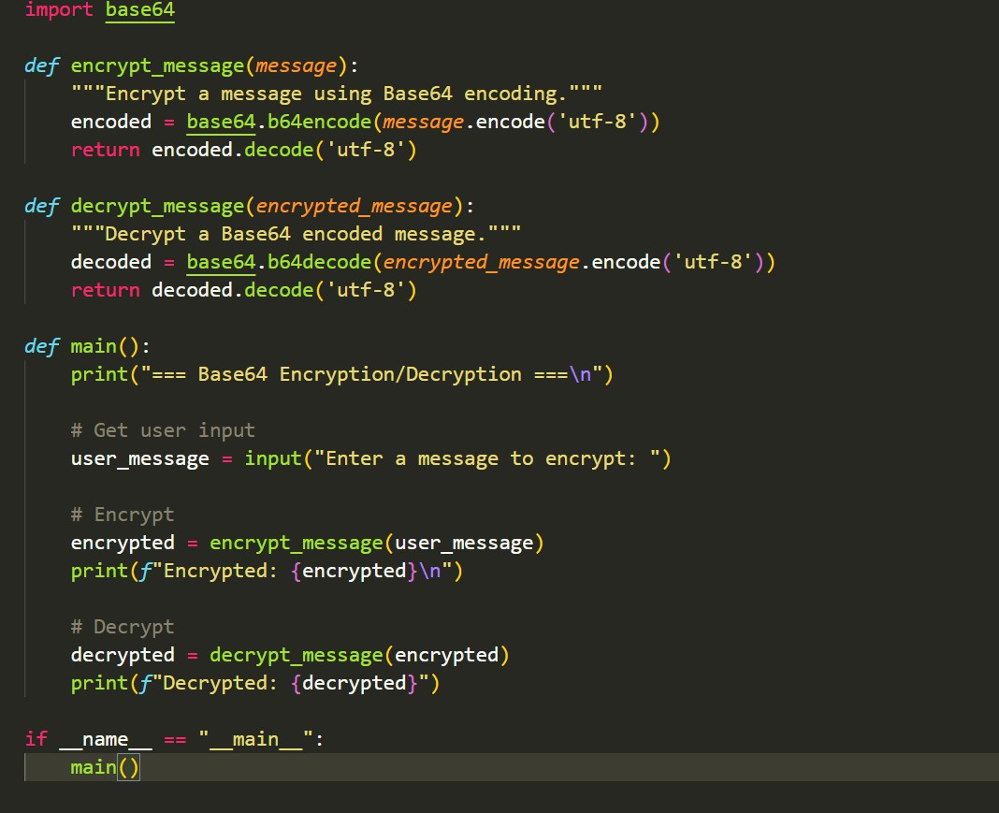
Explanation-
The AI-generated program used weak encryption techniques such as Base64 encoding, which is not true encryption but simple encoding that can be easily reversed. This makes sensitive data vulnerable to attacks. The improved version uses strong encryption methods
such as Fernet from the cryptography library, which provides secure symmetric encryption. This ensures that data can only be decrypted using the correct key, significantly enhancing data protection.
Task 4 – Real-Time Application: Security Review of AI-Generated Web Service
Scenario:
Students select an AI-generated web service snippet (e.g., REST API, file upload handler, or authentication module).
Prompt used:
Generate a simple Flask web application with a login system and database interaction.

Then perform a security review of the generated code:
- Identify at least three vulnerabilities such as:
  - SQL Injection
  - Lack of input validation
  - Hardcoded credentials

- Improve the code by:
  - Using parameterized queries
  - Validating user inputs
  - Removing hardcoded sensitive data

- Provide:
  - The improved secure version of the code
  - Explanation of vulnerabilities found
  - Explanation of the fixes applied

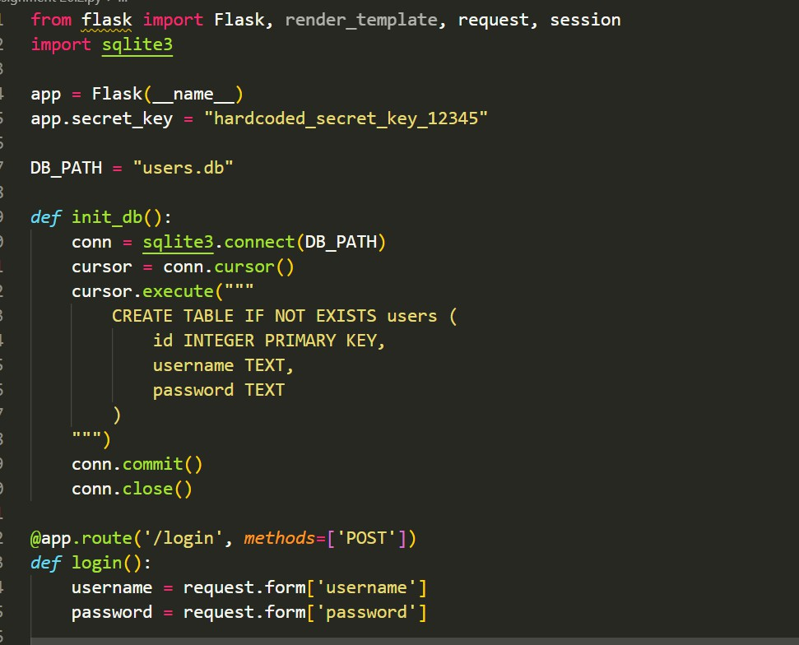

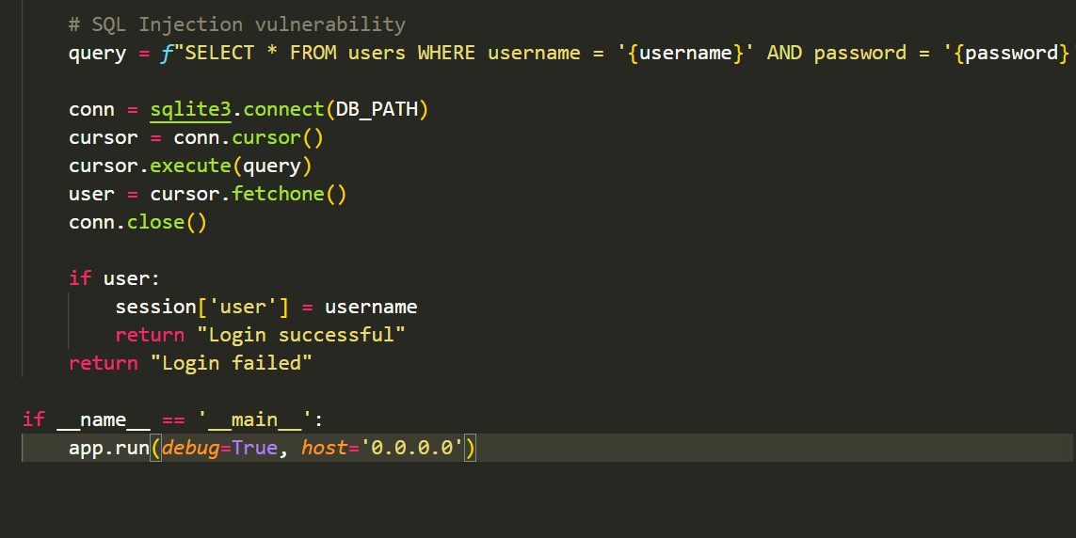
Explanation-
The AI-generated web service contained multiple security vulnerabilities, including SQL
injection, lack of input validation, and hardcoded credentials. SQL injection allows attackers to manipulate database queries, while missing validation can lead to malicious input

exploitation. Hardcoded credentials expose sensitive data. These issues were fixed by using parameterized queries, validating user inputs, and securely managing credentials. The improved version enhances application security, prevents unauthorized access, and ensures safe handling of user data.
Task 5 – Exception Handling Improvement Task:
Analyze an AI-generated Python program that does not handle runtime errors and improve its reliability.
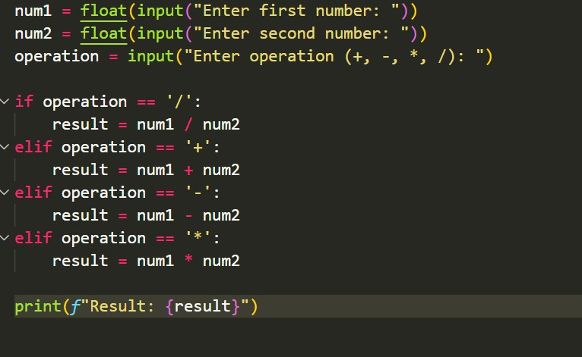
Explanation-
The initial program did not handle runtime errors, which could cause the application to crash when invalid input is provided or when division by zero occurs. This reduces reliability and
user experience. By implementing try-except blocks, the program can catch and handle exceptions gracefully. It provides meaningful error messages and prevents abrupt
termination, making the application more robust and user-friendly.

